- User Requirement:

A Shopify apps called “VKS Shipping Rates” to allow a Shopify Admin user to create different shipping rate as at the Home->apps area after login to Shopify Admin backend.

- Each Shipping Rate will include the following fields
- Zone Name: Contain of maximum 30-50 characters
- Country and regions: a dropdown menu containing a list of countries in which each country provides a list of regions in dropdown menu format for the user to click to choose
- District: the user can input a list of district name which can be separated by a “comma”. E.g. Wong Tai Sin, Tin Hau, Wan Chai
- Mathematical operator: Greater than & equal to , Less than & equal to
- Purchase Threshold amount: it is a numeric value
- Shipping fee: the default fee to charge the customer when the purchase threshold amount criteria is met
- Enable or Disable flag: A dropdown list for the user to set it Active when “Enable” flag is chosen and vice versa
- The number of Shipping rate record can be created by the Shopify Admin whenever there is a need.

- VKS Shipping Rates apps background:
The first phase of the VKS Shipping Rates apps is designed for Hong Kong only. Hong Kong has 3 regions, namely:
- Hong Kong Island
- Kowloon
- New Territories
And there are 18 districts among these 3 regions. There is no postcode in Hong Kong

- VKS Shipping apps’ 1. Navigation path:
- After the user login to Shopify backend, the VKS Shipping Rate apps can be access as follows:
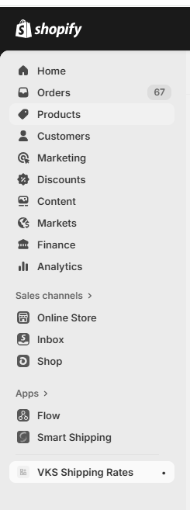

- Input of Shipping zone
- The admin user can click “Add shipping zone” icon to create new shipping fee
- Input user interface to create new shipping zone, part 1
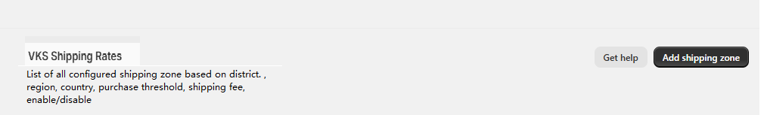
- Input detail of a new shipping zone, part 2
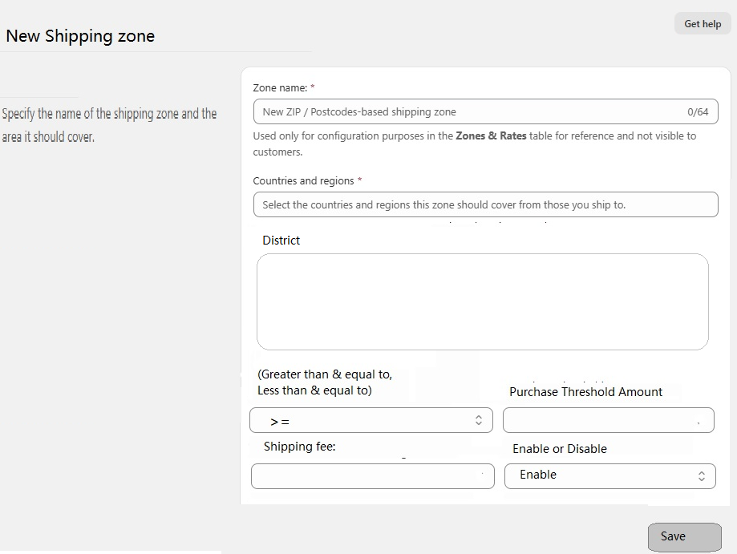

- Input the “Zone Name”
- Select Country and regions from a dropdown menu where a list of country with the regions associated with that country can be clicked to select.
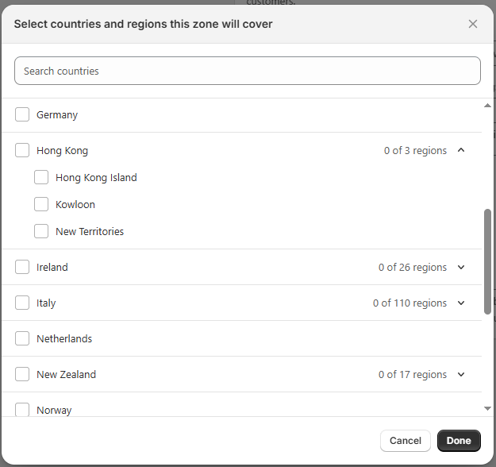
- Input of District
- Select “Greater than & equal to” or “Less than & equal to” operator
- Input the Purchase Threshold amount
- Input the shipping fee
- Select the “Enable” or “Disable” flag

- Listing of the Shipping zone created:
- All created shipping rate entries will be listed as the following sample screen
